វិទ្យាស្ថានបច្ចេកវិទ្យាកម្ពុជា

Institute of Technology of Cambodia

Department of Information and Communication



Subject: Internet Programming

Professor: HOK TIN

Assignment: TP1 (HTML & CSS)

Name: LAY Vicha

ID: e20190494

Group: I4-GIC-B

2022-2023

Contents

1. EX1-Basic Layout 1

2. EX2-Centering a “div” in a container (position) 2

3. EX3-Centering a “div” in a container (flex) 3

4. EX4-Column and Row (flex) 4

5. EX5-Column and Row (grid) 4

6. EX6-Responsive (media only screen) 5

7. EX7-Responsive (clamp) 6

8. EX8-Animation & Variable 7

9. EX9-Scrollable content 8

10. EX10-Scrollable content 9

11. EX11-Scrollable content 10

12. EX12-Scrollable content 11

# EX1-Basic Layout

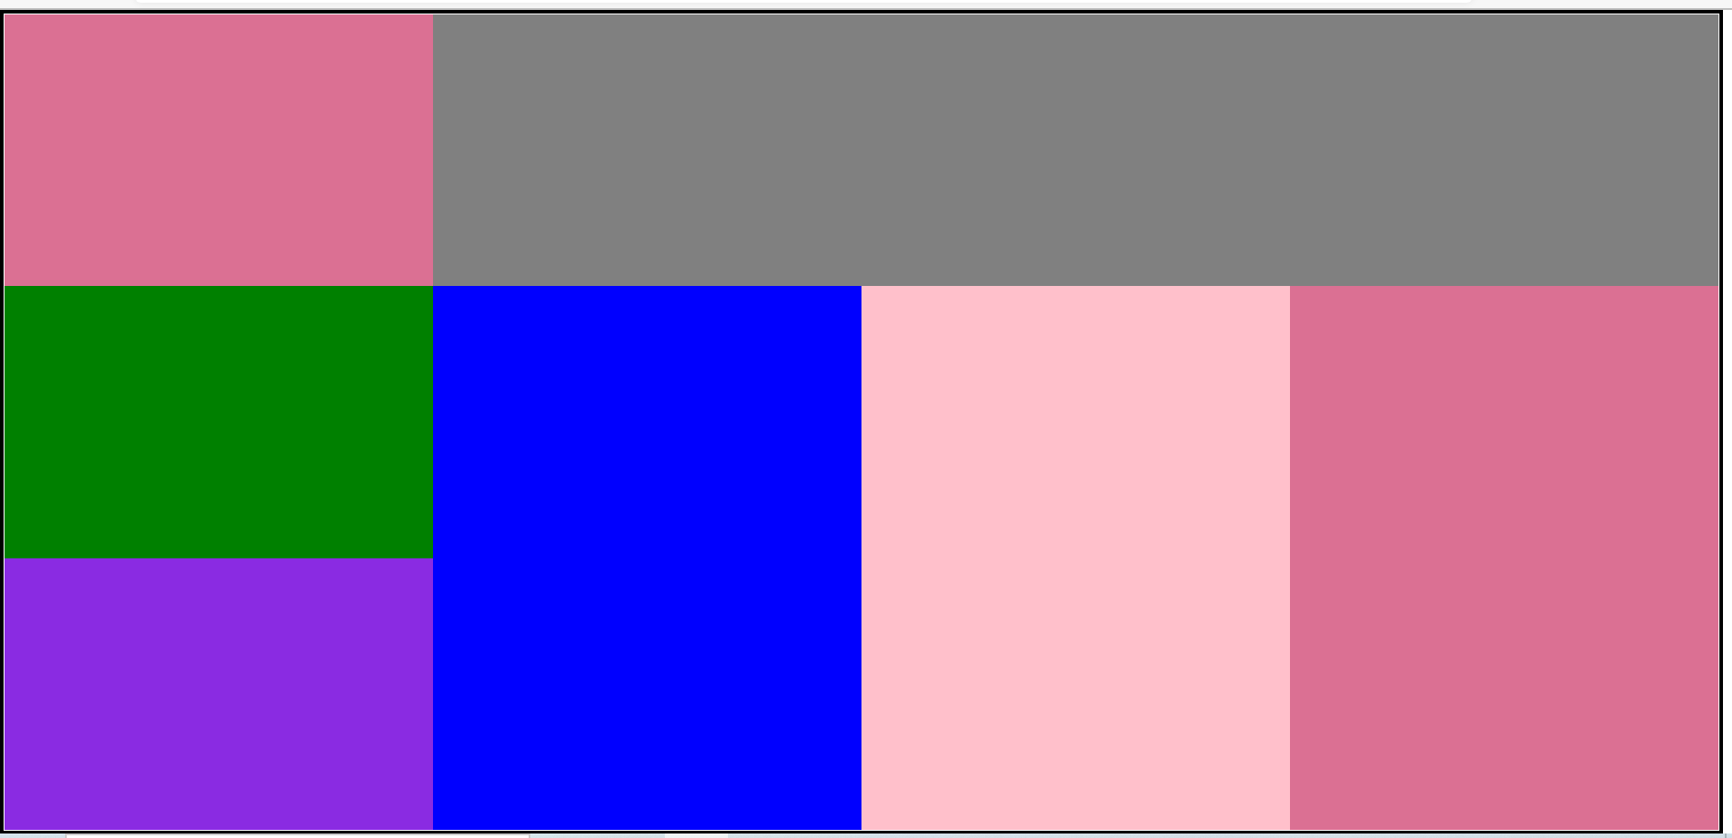

# EX2-Centering a “div” in a container (position)



# EX3-Centering a “div” in a container (flex)



# EX4-Column and Row (flex)

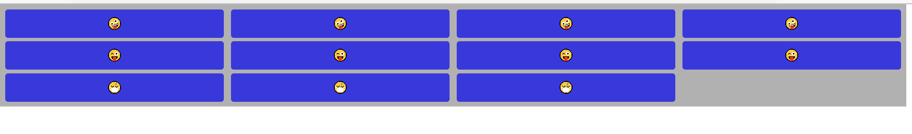

# EX5-Column and Row (grid)

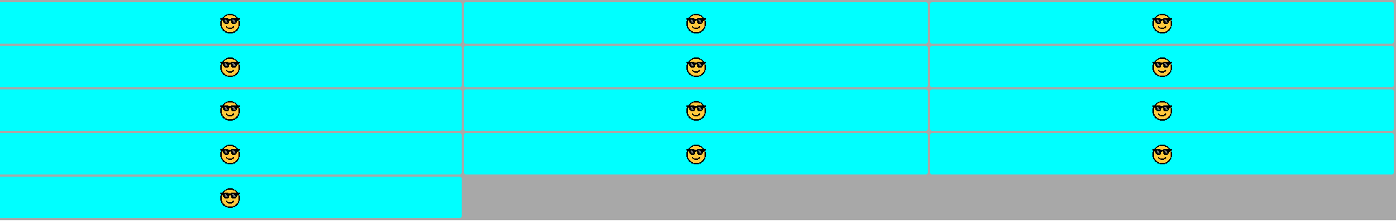

# EX6-Responsive (media only screen)

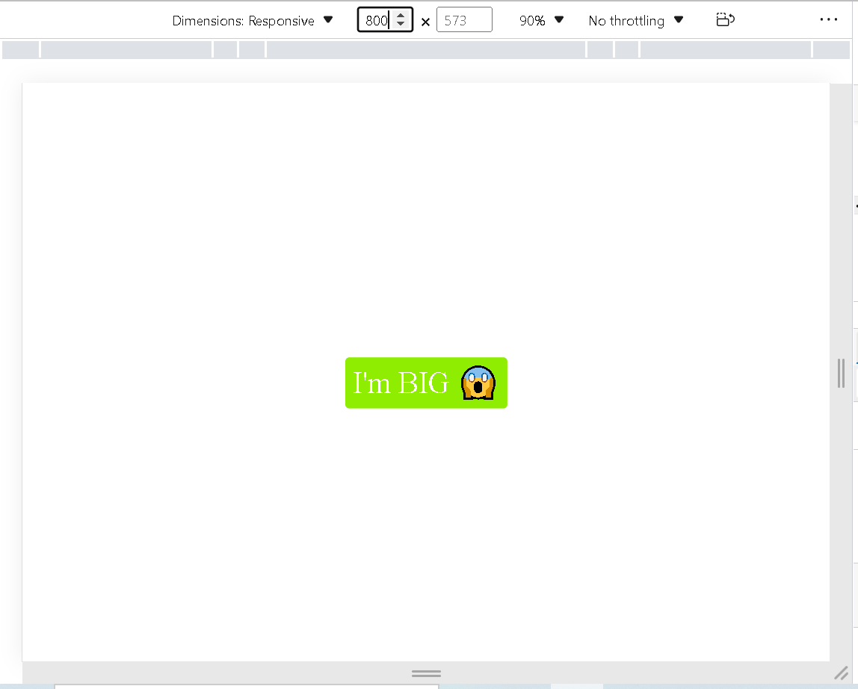

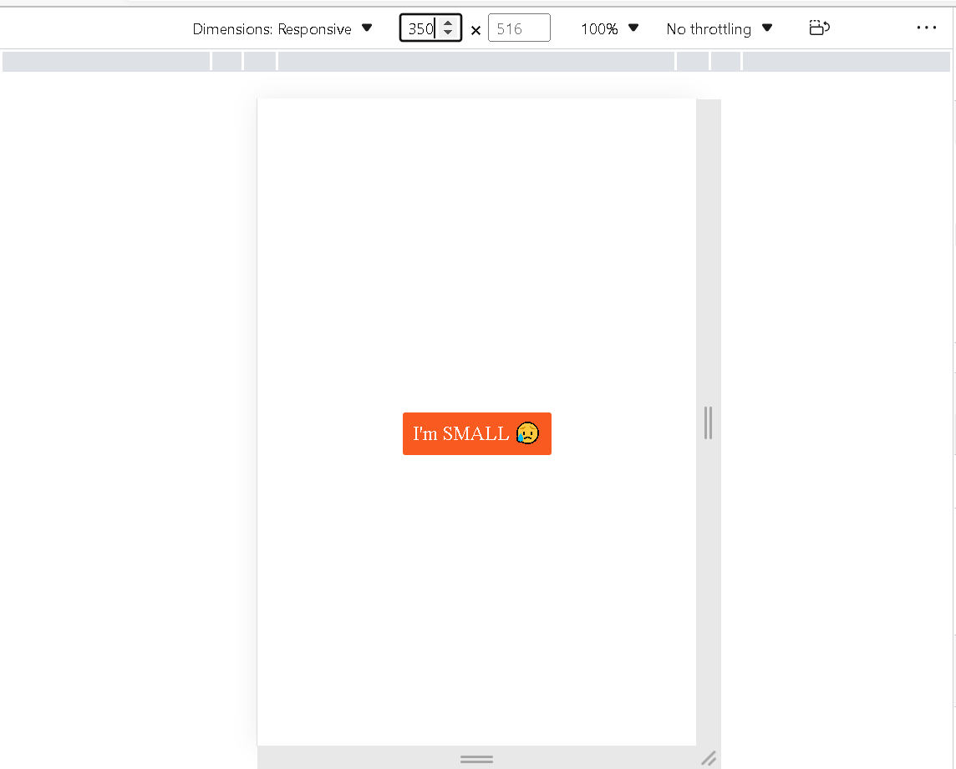

# EX7-Responsive (clamp)

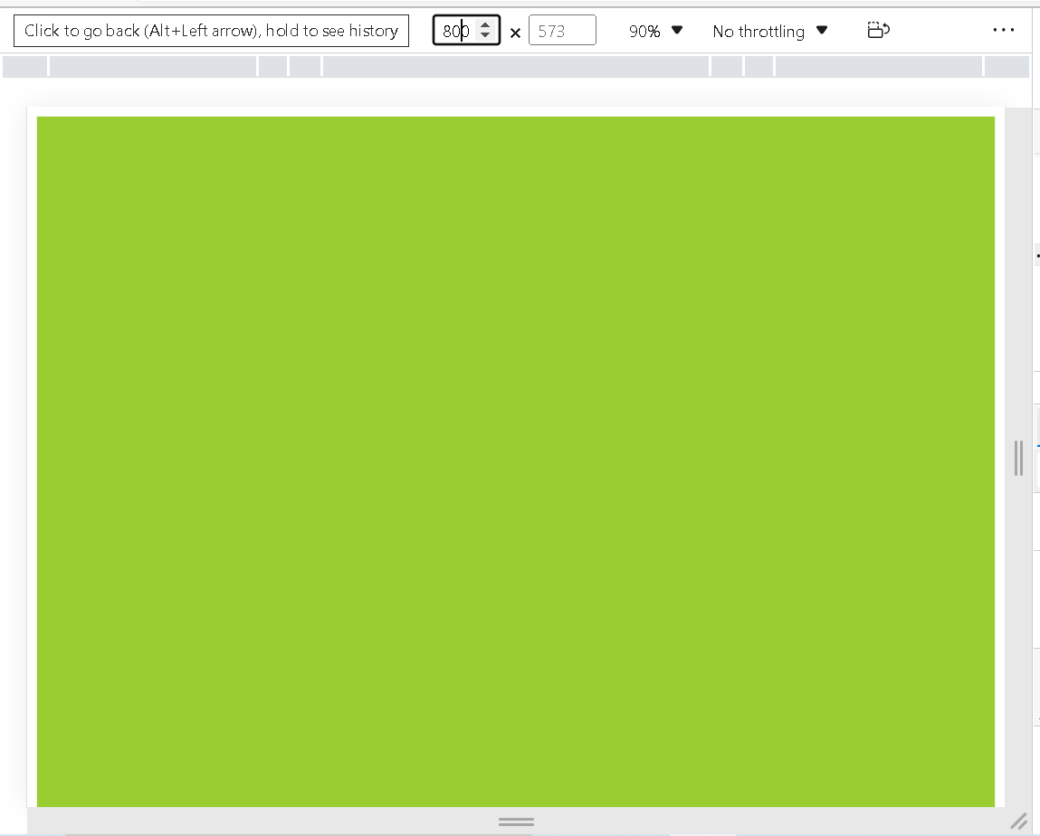

# EX8-Animation & Variable





# EX9-Scrollable content

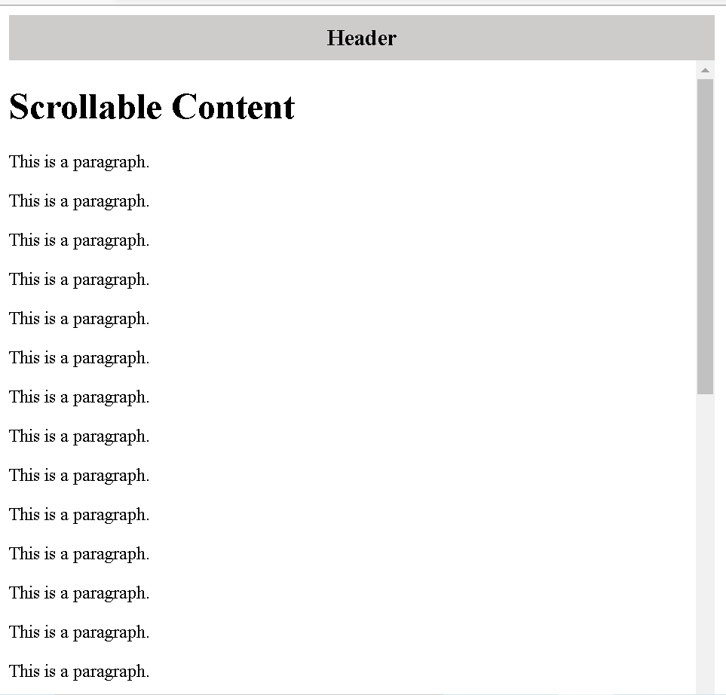

# EX10-Scrollable content

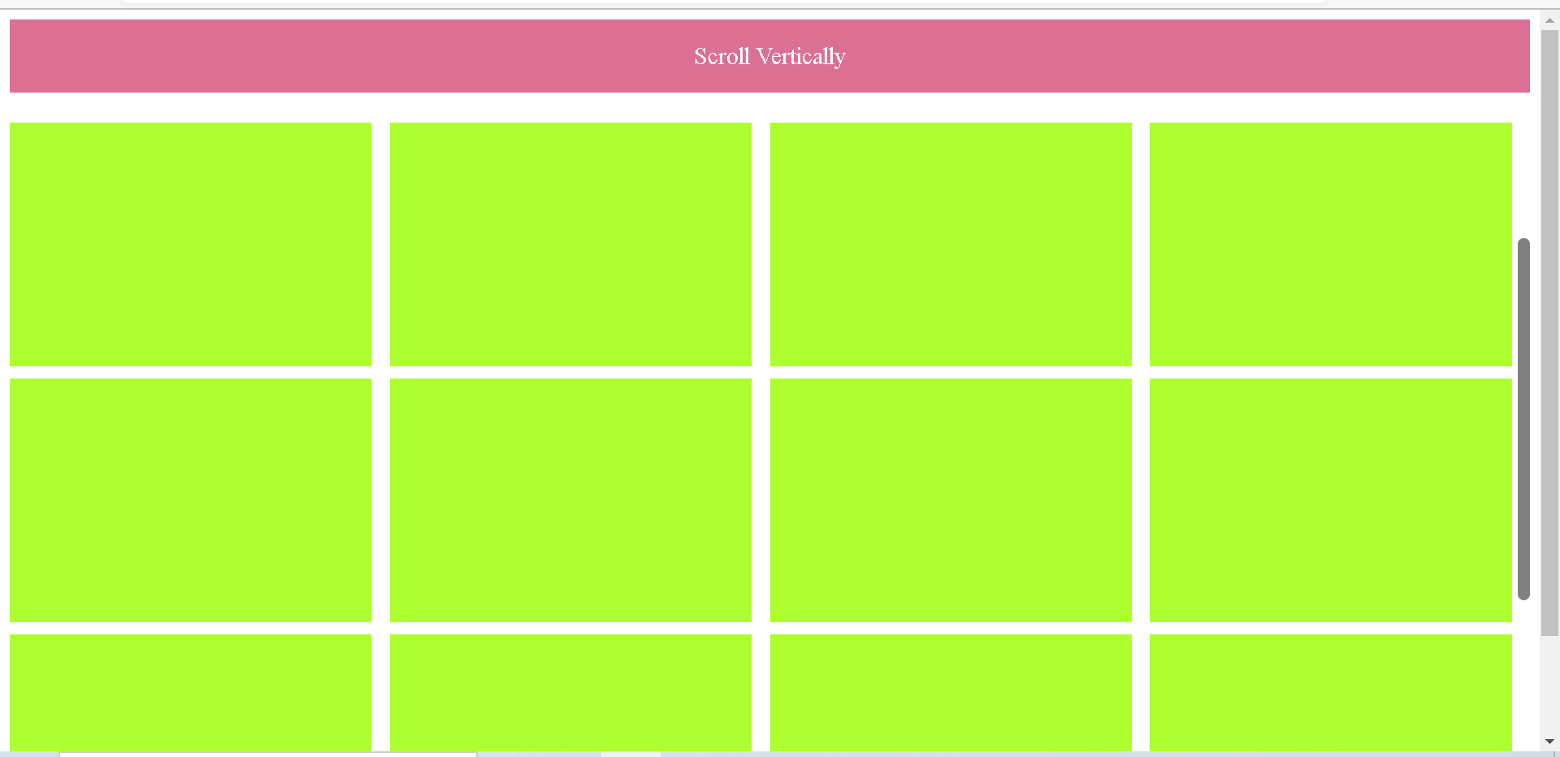

# EX11-Scrollable content

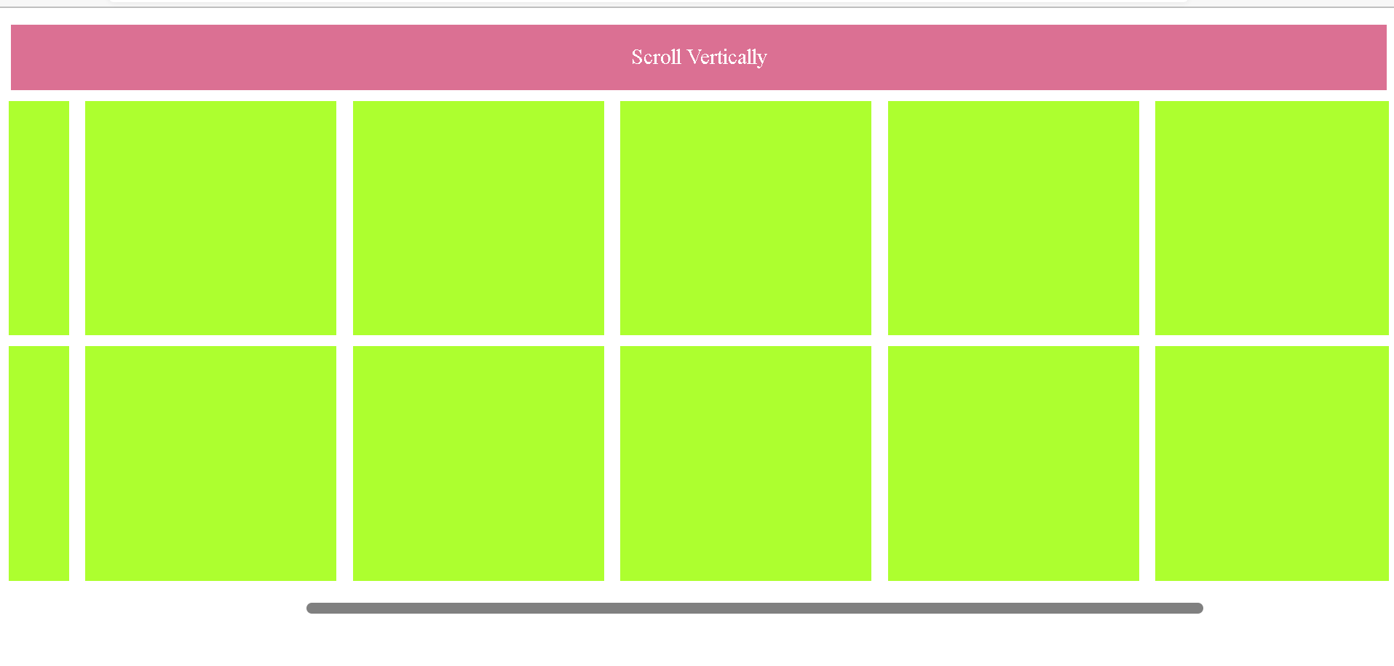

# EX12-Scrollable content

